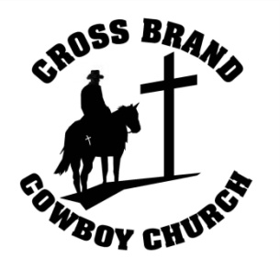
2013
Kids Ranch Rodeo Series
Rules and Information
January 20, February 17, March 17, April 21, and May 19

- Participant must meet the age requirements for each age group or at the parent’s discretion.
- 7 years & under or 8-12 years old
- Participant must have on file with us a Registration Form/Wavier of Liability.
- In order to be eligible for a KRRS Buckle, they must participate in at least 4 regular rodeos one being the final in May. $125 must be paid by the February 17th rodeo (no exceptions).
- The fee for a single rodeo is $25 regardless of how many events you participate in.
- All participants in riding events must ride by themselves. An adult may lead the contestant if necessary. All children who are NOT official participants must stay out of the arena.
- Each participant must be ready to run in assigned order per event. Each participant’s name and number will be called three times. If there is no response, we will move on to the next participant. You will not be added to the end of the order for that event. There will be no exceptions!
- Participants must comply with the KRR dress code
- Western attire: Boots and long sleeve button up shirts with collars,
- Hats are optional, but only western style hats are permitted. No baseball caps!
- 7 & under will begin at 1:00pm. The sign in books will open at 12:00pm and close at 1:00pm or you can pre-register at the previous rodeo.
Events include:
- Clover leaf Barrels- Please keep the alley way cleared during this event
- Cattle Penning- The participant will pen cattle. They will take a heard of cattle (5head) and move them from one pen to another. Will try to stay in number order.
- Goat Roping, Flipping and Branding – The participants will be grouped into 3. One will rope a goat while the second will flip the goat and the third will brand the goat.
- Mutton Busting- The participant will wear a flack jacket and helmet provided by KRR, then hold on tight!
- Dummy Roping- Each contestant will try 3 times to rope a dummy steer
- 8-12 year olds will begin at 1:15pm. Books will open up at 12:00. Or you can pre-register at the previous rodeo.
Events include:
- Cloverleaf Barrels- Please keep the alley way cleared during this event
- Cattle Sorting/Roping- The participant will enter a herd of cattle and have the option to rope with a break-away hondo or sort the drawn number within a two minute time limit. No tying off to the horn. Will try to go in number order.
- Calf Roping/Flipping & Branding. The participants will be grouped into 4. One will rope a calf while two will attempt to flip the calf and the 4th will brand the calf within a two minute time limit.
- Calf Mugging- The participant will be put into a bucking shoot with a calf. When the gate opens, the participant must hold on to the calf and wrestle it to the ground. (Mouth Piece Recommended)
- Dummy Tie down/Roping- practice roping and tying down a dummy calf/goat
- Negative Coggins Test Required
- This is non competitive rodeo. Everyone’s a winner!

For more info call David Gilleland 903-570-3525 or Cross Brand Cowboy Church 903-535-9155

